CHELMER VILLAGE SURGERY
NEW PATIENT HEALTH QUESTIONNAIRE
Your up-to-date medical records will take a few weeks to arrive from your previous doctor so please complete the form as best you can to help us look after you in the meantime. You will need to provide one proof of ID i.e. Driving Licence/Passport AND one Proof of address, i.e. Utility Bill/Bank Statement. This will avoid a delay in your registration. Please circle/tick where appropriate.
Confidentiality Statement
We hold your patient records in the strictest confidence, regardless of whether they are electronic or on paper. We take all reasonable precautions to prevent unauthorised access to your records, however they are stored. Any information that may identify you is only shared with the practice team, or, if you are referred to hospital, to the clinician who will be treating you. We will only share information about you with anyone else if you give your permission in writing.

1. PERSONAL DETAILS

Surname………………………………………. First Names(s)…………………………………..

Home Telephone………………………………… Mobile………………………………………………

Email Address…………………………………………………………………………………………………..

Date of Birth…………………………………. Place of Birth…………………………………….

Occupation…………………………………………

Ethnicity.............................................

The Government wishes us to record your ethnic background, please tick the background closest to your own: (Please circle your chosen ethnic group or use the space provided to describe your ethnic group if a precise match is not available.)
White
1. English / Welsh / Scottish / Northern Irish / British
2. Irish
3. Gypsy or Irish Traveller
4. Any other white background (please describe)
Mixed / Multiple ethnic groups
5. White & Black Caribbean
6. White & Black African
7. White & Asian
8. Any other Mixed / Multiple ethnic background (please describe)
Asian / Asian British
9. Indian
10. Pakistani
11. Bangladeshi
12. Chinese
13. Any other Asian background (please describe)
Black / African / Caribbean / Black British
14. African
15. Caribbean
16. Any other Black / African / Caribbean background (please describe)
Other Ethnic Groups
17. Arab
18. Any other ethnic group (please describe)

Main Spoken Language …………………………………..

GENDER: (Please circle)

Male (including Tran’s men) / Female (including Trans women)

Non-binary / In another Way (Please Specify) ________________________

Is this the gender you were assigned at birth? Yes / No

Sexual Orientation: Lesbian or Gay /Straight or Heterosexual /Bisexual/other

2. ARE YOU A CARER?

Do you look after someone who is ill, frail or disabled? Yes/No

Are you cared for by someone else? Yes/No

If YES,

Name: ……………………………………………

Their contact telephone number: ………………………………………..

3.IF OVER THE AGE OF 13, PLEASE RECORD:

Height: …………………… Weight: ……………… Waist Measurement: …………….

3. CURRENT SMOKING STATUS:

□ Never smoked
□ I currently smoke (on average) ___________ cigarettes per day, or _______ oz. of tobacco per week.
□ I am an ex-smoker. I gave up in __________ (year).

If you are currently a smoker but are considering stopping, an information leaflet is available at reception for advice and tips on stopping smoking.

If you smoke and would like help giving up please phone the NHS Quit line on 0800 00 22 00

We want to get better at communicating with our patients. We would like to ensure you can read and understand the information we send you. If you find it hard to read our letters or if you need someone to support you at appointments, please let us know if you have any Special Communication Needs? E.g. BSL interpreter for hearing impairment or large print/braille or you lip read or use a hearing aid or communication tool.

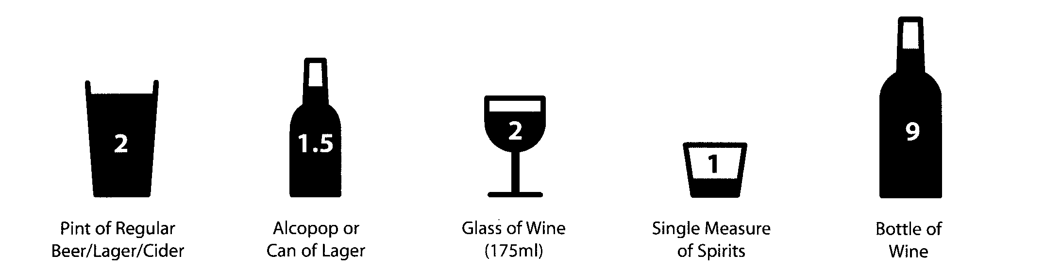
5. ALCOHOL

Please answer the following 3 questions. Circle the answer that best describes your drinking habits.
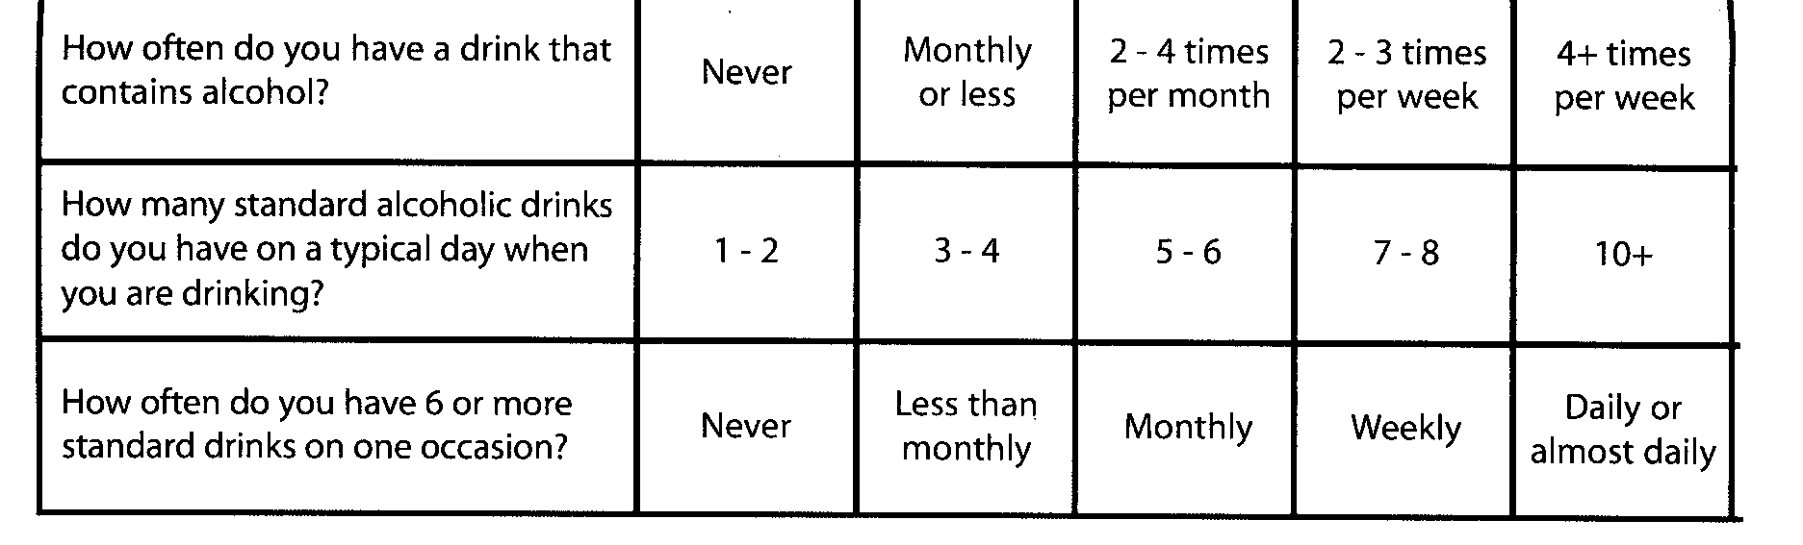

4. ALLERGIES

Are you allergic to any medications / Food? Yes/No

If so, which ones: …………………………………………..

What happens if you take them: ....................................................

EXERCISE

Do you take exercise: Yes/No Inactive Moderate Vigorous

DIET: ……………………………

4. PERSONAL MEDICAL HISTORY

Have you ever suffered from any of the following?

Epilepsy Yes/No High Blood Pressure Yes/No
Glaucoma Yes/No Cancer Yes/No Where……………….
Diabetes Yes/No Asthma Yes/No When………………..
Heart Attack or Angina Yes/No
Strokes Yes/No
Mental Health Problems Yes/No

Learning Disabilities: Yes / No Mild Moderate Severe

Please give details of any other serious illness or any time you have stayed in hospital including dates where possible:-

DATE | PROBLEM

3. MEDICINES

Are you taking any drugs or medicines? Yes/No

Please tell us the names and dose and how often you take the medicines.
NB You must make an appointment to see the Doctor before we issue you with a repeat prescription.

Do you have a nominated pharmacy, if so what is the name __________________

WE RESERVE THE RIGHT TO RECONSIDER PRESCRIBING ANY OF YOUR EXISTING MEDICATION AT A FIRST CONSULTATION.

6. FAMILY MEDICAL HISTORY

Has any close first degree relative of yours suffered from any of the following?

Epilepsy Yes/No High Blood Pressure Yes/No

Glaucoma Yes/No Cancer Yes/No

Diabetes Yes/No Heart Attack or Angina Yes/No

Strokes Yes/No Asthma Yes/No

Please give more details…………………………………………………………………………………………….

8. VACCINATIONS

Have you had polio and tetanus booster? Yes/No

Polio Date…………… Tetanus Date…………….. BCG Date……………………

10. WOMEN, TRANS MEN AND NON-BINARY PEOPLE WITH A CERVIX (OR OTHER PEOPLE WITH A CERVIX

Have you had a cervical smear Yes/No When was the last one Date………………

What was the result: Normal / Abnormal

Have you had a hysterectomy: Yes / No

Where Your Ovaries Removed: Yes / No

Date of Last Mammogram: …………………………

CONTACTING YOU:

Please state your preferred method of contact (please tick) Home Mobile

SMS Messaging Email

Or any of the above

11. NEXT OF KIN

Name………………………………………………….. Telephone……………………………….

We would only contact your next of kin in an emergency. We do not divulge confidential information to anyone without your permission.

Please complete form attached if you would like a family member, friend or carer to receive information on your behalf.

Would you like a friend or relative to receive information on your behalf? If so please complete below:

Patient Name:
Date of Birth:

- Name:
Address:
Date of Birth:
Contact No:
Relationship to you:

ALL
Medical Information
ONLY
Test Results
ONLY
Collect Prescriptions/ Letters
Please be aware that this information can be altered at any time by putting your wishes in writing to the surgery

I hereby give explicit consent for the above named person/s to have access to the following information:
Please TICK the relevant box below:

Signed: ………………………… Dated: ………………………
Please be aware that those named above will be asked for identifiable information when contacting the surgery by telephone and photo Id when collecting Prescriptions, Letters & Patient Data from the surgery.

Application for online access (called Patient Online)
For all registered patients aged 16 and over
Surname | Date of birth
First name
Address

Postcode
Email address
Telephone number | Mobile number

I wish to have access to the following online services (please tick all that apply):
Booking appointments | □
Requesting repeat prescriptions | □
Accessing my medical record | □

I wish to access my medical record online and understand and agree with each statement (tick)
- I have read and understood the information leaflet provided by the practice | □
I will be responsible for the security of the information that I see or download | □
If I choose to share my information with anyone else, this is at my own risk | □
I will contact the practice as soon as possible if I suspect that my account has been accessed by someone without my agreement | □
If I see information in my record that is not about me or is inaccurate, I will contact the practice as soon as possible | □
If you think that you may come under pressure to give access to someone else unwillingly at any time, please inform a member of the practice team as soon as possible.

Signature | Date

For practice use only
Patient NHS number |  | Patient Date of Birth
Identity verified by  (initials) | Date | Method  Proof of address (compulsory)□  PLUS one form of photo ID  Photo ID – Driving License □  Photo ID – Passport □  Photo ID – Other (please state)…………… □
Registration completed by (initials) |  |  | Date
Date password and username document collected: (if done in patient’s absence)

Patient Online Access Leaflet
If you wish to, you can now use the internet to book appointments, order repeat prescriptions for any medications you take regularly and look at your medical record online including recent tests.
It also means that you can even access it from anywhere in the world, should you require medical treatment on holiday for example.
If you do not wish to use this service or if you choose to withdraw, this is your choice and will not affect the quality of your care.
You will be given logon details including a temporary password, which you will need to change to a memorable one. This will ensure that only you are able to access your records, unless you choose to share your details with a family member or carer.
It will be your responsibility to keep your logon details and password safe and secure. If you know or suspect that your record has been accessed by someone that you have not agreed should see it, you should change your password immediately.
If you are unable to change your password, we recommend that you contact the practice and ask for your online access to be removed until you are able to come in to the surgery to request a new password. Proof of ID will be required for this.
If you print out any information from your record, it is your responsibility to keep this secure. If you are worried about keeping printed copies safe, we recommend that you do not make copies at all.
Before you apply for online access to your records, there are some important things to consider.
Although the chances of any of these things happening are very small, you will be asked to confirm that you have read and understood the following before you are given logon details.
Things to consider:
- Forgotten history – There may be something you have forgotten about in your records that you may find upsetting
- Abnormal results or bad news – If your GP has given you access to test results or letters, you may see something that you find upsetting. This may occur before you have spoken to your doctor or whilst the surgery is close and you cannot contact them.
- Choosing to share your information with someone – It is up to you whether or not you share your information with others, perhaps family members or carers. It is your choice, but also your responsibility to keep the information safe and secure.
- Coercion – If you think you may be pressured into revealing details from your patient record to someone else against your will, it is best that you do not register for access at this time.
- Misunderstood information – Your medical record is designed to be used by clinical professionals to ensure that you receive the best possible care. Some of the information within your record may be highly technical, written by specialists and not easily understood. If you require further clarification you should contact your GP.
- Information about someone else – If you spot something in the record which is not about you, or notice any other errors, please log out of the system immediately and contact the practice as soon as possible.

