Chelmer Primary Care Network
A collaboration of four GP practices serving approximately 39,000 patients from the Chelmsford, Great Baddow, Chelmer Village and Springfield areas.
GP Practices
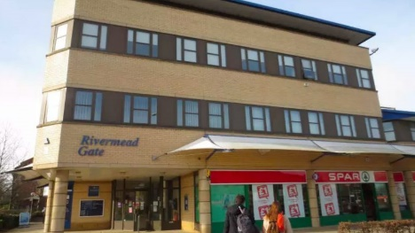
Rivermead Gate Medical Centre

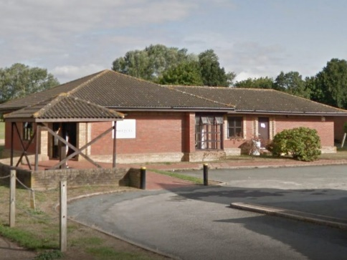
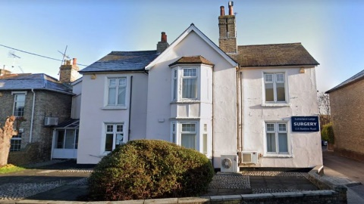
Sutherland Lodge Surgery
Chelmer Village Surgery
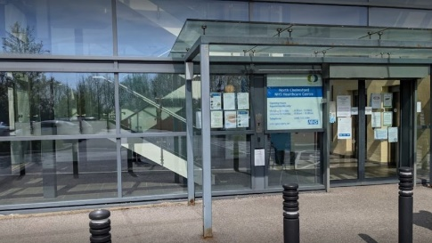
North Chelmsford Healthcare Centre

What we Do
Find out what a Primary Care Network (PCN) is and what it does for your community.

What is a Primary Care Network?
Primary Care Networks (PCN) offer a new way of organising care, bringing together all local health and care services in a local area to deliver more joined up care to local populations (usually covering around 50,000 people)
When fully developed, PCNs will include:
- GP services
- Pharmacies
- Community health services
- Mental health services
- Adult social care
- Voluntary organisations

NHS Long Term Plan
The majority of PCNs were set up in July 2019 as a response to the NHS Long Term Plan published in January 2019, which proposed a new way of delivering health and care services. It has been driven by the need to create a more joined-up, less fragmented approach to health and care, making it more personal and closer to where they live.

What can you expect from your PCN
Additional healthcare professionals are being recruited to work on behalf on Primary Care Networks. New roles include Advanced Nurse Practitioners, Clinical Pharmacists, Mental Health professionals and Social Prescribing Link Workers. By introducing a greater skill mix, local people will get more access to the support they need to keep people healthy and independent. See Who we are page for more information about the roles that are available in this PCN.
The ultimate aim is to deliver better health outcomes for the local population, as well as a reduction in health inequalities.
In the future, we will also see doctors, nurses and healthcare professionals working collectively to try to anticipate a patient’s needs, to avoid getting unwell in the first place. This will be part of a wider campaign to make people aware of the importance of taking better care of themselves to avoid future health issues.

Meet the Team
Find out about the team in your Primary Care Network (PCN)
Management Team:
Dr Yadav – Clinical Director
Georgina Morgan – PCN Manager
Paramedics:
Lucy Whybrow
Tom Dougal
Sarah Dunlevey
Physician Associate:
Jody Hinchcliffe
Clinical Pharmacists
Krystyna Drelich- Lead Advanced Pharmacist Practitioner
Priti Patel
Berly Chacko
Mariam Hazeez
Priya Chopra
Pharmacy Technician
Yatin Patel
Social Prescriber
Chloe Hall
Health & Wellbeing Coach
Chris Allen
Cancer Care Co-Ordinator
Rebecca Hammond

Mental Health Team
Adult
Juliette Amakye - Addo
Amanda Gosling
Children & Young Persons
Lisa French
Our Vision, Values & Ambitions
The vision, values & ambitions of our Primary Care Network (PCN)

Vision & Strategy
- Empower primary care and working in partnership to facilitate access to high quality, clinically effective and fully integrated care for everyone.
- Ensure a sustainable health service for our local community.

Values
- Collaborative team working
- Fair and equitable
- Open and transparent

Ambition
- Support and sustain general practice.
- Work with our patients to provide individualised, responsive care.
- Reduce health inequalities across the network.
- Aim to ensure equity of quality and access to care all residents of the Chelmer PCN.
- Work collaboratively with each other and build relationships with our local health and social care provides within the Integrated Care System.
- Facilitate our member practices to play their role in delivering better, more effective care.
- Deliver innovative programmes that help our patients manage and improve their long-term conditions.

Accessing Appointments Out of Hours
GP practices across Chelmer Primary Care Network are working together to provide the right services at a time which is convenient for you. We’ve listened to feedback from people in our local area and we are making changes to our out-of-hours appointments to deliver better services for you.
The new way of delivering out-of-hours appointments will give you:
- Access to more healthcare professionals. This new service will be delivered by professionals including GPs, nurses, healthcare assistants and nurse practitioners.
- More choice about the type of appointment you want. These include a mixture of in-person face-to-face appointments and remote appointments like telephone, video, or online appointments.
- Make it more convenient for you to travel to out-of-hours appointments. These appointments are being planned and delivered locally, so it is likely they will available closer to your home.
From Saturday 1 October 2022, out-of-hours appointments will be available from 6.30pm to 8pm on weekdays and from 9am to 5pm on Saturdays.
When we asked local people what you wanted from these appointments you told us that as well as being able to see a GP, you would also like access to a range of other clinical appointments. In response we have been able to design an offer where we can continue to deliver the majority of our core services.
Out-of-hours appointments were previously planned by Clinical Commissioning Groups (CCGs) on behalf of many GP practices in a bigger area. From Saturday 1 October 2022, this is now being planned and delivered locally by Primary Care Networks (PCNs).
An out-of-hours appointment might not be at your regular GP surgery. When you book an appointment, you will be told where the appointment will be.
These appointments will not be available as walk-in appointments. You will need to book them in advance.
To book an out-of-hours appointment, you should contact your regular GP practice in the usual way. They will advise you on the appointments which are available, and which healthcare professional is the right person to help you.
If you need medical help now but it’s not an emergency, you can also go to NHS 111 online or call 111.

